wf=0.2\*pi;

t=0:0.001:10;

角度均为弧度制

q1 = x(11) + x(1)/wf\*sin(wf\*t)-x(2)/wf\*cos(wf\*t)+x(3)/(2\*wf)\*sin(2\*wf\*t)-x(4)/(2\*wf)\*cos(2\*wf\*t)

+x(5)/(3\*wf)\*sin(3\*wf\*t)-x(6)/(3\*wf)\*cos(3\*wf\*t)+x(7)/(4\*wf)\*sin(4\*wf\*t)-x(8)/(4\*wf)\*cos(4\*wf\*t)+x(9)/(5\*wf)\*sin(5\*wf\*t)-x(10)/(5\*wf)\*cos(5\*wf\*t);

dq1 = x(1)\*cos(wf\*t)+x(2)\*sin(wf\*t)+x(3)\*cos(2\*wf\*t)+x(4)\*sin(2\*wf\*t)+x(5)\*cos(3\*wf\*t)

+x(6)\*sin(3\*wf\*t)+x(7)\*cos(4\*wf\*t)+x(8)\*sin(4\*wf\*t)+x(9)\*cos(5\*wf\*t)+x(10)\*sin(5\*wf\*t);

ddq1 = -x(1)\*wf\*sin(wf\*t) + x(2)\*wf\*cos(wf\*t) - x(3)\*2\*wf\*sin(2\*wf\*t) + x(4)\*2\*wf\*cos(2\*wf\*t)

- x(5)\*3\*wf\*sin(3\*wf\*t) + x(6)\*3\*wf\*cos(3\*wf\*t) - x(7)\*4\*wf\*sin(4\*wf\*t) + x(8)\*4\*wf\*cos(4\*wf\*t)

- x(9)\*5\*wf\*sin(5\*wf\*t) + x(10)\*5\*wf\*cos(5\*wf\*t);

q2=x(22)+x(12)/wf\*sin(wf\*t)-x(13)/wf\*cos(wf\*t)+x(14)/(2\*wf)\*sin(2\*wf\*t)-x(15)/(2\*wf)\*cos(2\*wf\*t) + x(16)/(3\*wf)\*sin(3\*wf\*t) - x(17)/(3\*wf)\*cos(3\*wf\*t)+

x(18)/(4\*wf)\*sin(4\*wf\*t)-x(19)/(4\*wf)\*cos(4\*wf\*t)+x(20)/(5\*wf)\*sin(5\*wf\*t)-x(21)/(5\*wf)\*cos(5\*wf\*t);

dq2=x(12)\*cos(wf\*t)+x(13)\*sin(wf\*t)+x(14)\*cos(2\*wf\*t)+x(15)\*sin(2\*wf\*t)+x(16)\*cos(3\*wf\*t)+x(17)\*sin(3\*wf\*t)+x(18)\*cos(4\*wf\*t)+x(19)\*sin(4\*wf\*t)+x(20)\*cos(5\*wf\*t)+x(21)\*sin(5\*wf\*t);

ddq2 = x(12)\*wf\*sin(wf\*t) + x(13)\*wf\*cos(wf\*t) - x(14)\*2\*wf\*sin(2\*wf\*t)+x(15)\*2\*wf\*cos(2\*wf\*t)

* x(16)\*3\*wf\*sin(3\*wf\*t) + x(17)\*3\*wf\*cos(3\*wf\*t) - x(18)\*4\*wf\*sin(4\*wf\*t)

+ x(19)\*4\*wf\*cos(4\*wf\*t) - x(20)\*5\*wf\*sin(5\*wf\*t) + x(21)\*5\*wf\*cos(5\*wf\*t);

q3=x(33)+x(23)/wf\*sin(wf\*t)-x(24)/wf\*cos(wf\*t)+x(25)/(2\*wf)\*sin(2\*wf\*t)-x(26)/(2\*wf)\*cos(2\*wf\*t)+x(27)/(3\*wf)\*sin(3\*wf\*t)-x(28)/(3\*wf)\*cos(3\*wf\*t)

+x(29)/(4\*wf)\*sin(4\*wf\*t)-x(30)/(4\*wf)\*cos(4\*wf\*t)+x(31)/(5\*wf)\*sin(5\*wf\*t)-x(32)/(5\*wf)\*cos(5\*wf\*t);

dq3=x(23)\*cos(wf\*t)+x(24)\*sin(wf\*t)+x(25)\*cos(2\*wf\*t)+x(26)\*sin(2\*wf\*t)+x(27)\*cos(3\*wf\*t)+x(28)\*sin(3\*wf\*t)+x(29)\*cos(4\*wf\*t)+x(30)\*sin(4\*wf\*t)+x(31)\*cos(5\*wf\*t)+x(32)\*sin(5\*wf\*t);

ddq3=-x(23)\*wf\*sin(wf\*t)+x(24)\*wf\*cos(wf\*t)-x(25)\*2\*wf\*sin(2\*wf\*t)+x(26)\*2\*wf\*cos(2\*wf\*t)-x(27)\*3\*wf\*sin(3\*wf\*t)+x(28)\*3\*wf\*cos(3\*wf\*t)-x(29)\*4\*wf\*sin(4\*wf\*t)

+x(30)\*4\*wf\*cos(4\*wf\*t)-x(31)\*5\*wf\*sin(5\*wf\*t)+x(32)\*5\*wf\*cos(5\*wf\*t);

第一组：

x[1] = -0.179050039083530

x[2] = 0.337912333425078

x[3] = 0.171887386116034

x[4] = -0.255559293055933

x[5] = -0.00651380374948211

x[6] = 0.0161055968145125

x[7] = 0.00147549492961256

x[8] = 0.000986457276365859

x[9] = 0.0122009617873660

x[10] = 0.0241887266275576

x[11] = 0.351072852429105

x[12] = 0.120217977915298

x[13] = -0.193015432622764

x[14] = 0.207065997472404

x[15] = -0.00241651400116285

x[16] = -0.328343700288920

x[17] = 0.0653126607113350

x[18] = 0.00105579744962090

x[19] = -0.00128536819297304

x[20] = 3.92745159661630e-06

x[21] = 0.00141039025259553

x[22] = -0.274529650621940

x[23] = 0.0417608793421279

x[24] = 0.0386035679949555

x[25] = -0.0640166429219427

x[26] = -0.332581363160303

x[27] = -0.0328662306566923

x[28] = 0.154562650500395

x[29] = 0.0225016334795022

x[30] = 0.0746750790992369

x[31] = 0.0326203607570049

x[32] = -0.0271658219144967

x[33] = -0.100157199917764

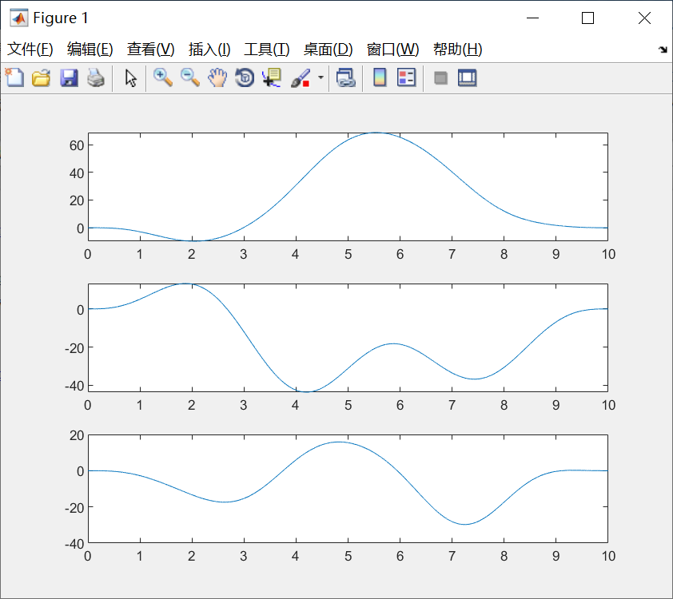

第二组

x[1] = -0.304580115391071

x[2] = 0.185019756628147

x[3] = 0.290965527621292

x[4] = -0.161357743543810

x[5] = -0.00994432309767740

x[6] = 0.00235777166943243

x[7] = 0.0236161283043299

x[8] = 0.0327548243743614

x[9] = -5.72174368730838e-05

x[10] = -7.93764092539199e-05

x[11] = 0.180321976861527

x[12] = 0.336586240835087

x[13] = 0.273277324215730

x[14] = -0.0900381896282011

x[15] = -0.172137633762897

x[16] = -0.179394186024574

x[17] = 0.0102713932186879

x[18] = -0.0670969307191612

x[19] = 0.0100507320921269

x[20] = -5.69344631511429e-05

x[21] = -3.83294290134443e-06

x[22] = 0.307398575826813

x[23] = 0.0269976452902748

x[24] = -0.000253460562740298

x[25] = 0.0290299068506253

x[26] = 0.401390339495448

x[27] = -0.0267874569829692

x[28] = -0.376289477226421

x[29] = 0.000846096681617728

x[30] = -0.000921889554741756

x[31] = -0.0300861918395486

x[32] = 0.0660057542940151

x[33] = 0.140028596343364

